Software Quality & Testing – COMP – 10066 – 03 Lab Report 3 – Automated Web-Site Testing

# By: Chao Zhang, 000306946

# Introduction

The purpose of this lab exercise is to test a website’s functionality using an automated testing software called Selenium. I will be this website’s primary and only tester for the duration of this exercise. This lab report will review the website’s functionality based on a test plan provided by me. I will also provide a detailed list of test cases along with test procedures to explain how to run automated tests in Selenium.

# Test Plan

The website I will be testing is <https://csunix.mohawkcollege.ca/tooltime/comp10066>

This website contains an Admin account and standard user accounts. I will be testing the correctness of the functionalities of these two types of users using the Selenium IDE.

# Test Suite ADMIN_1

Test Cases for Admin user

|  |  |  |  |  |
| --- | --- | --- | --- | --- |
| Test Name | Test Purpose | Expected Result | Observation | Status |
| Admin Login Logout | To verify the correct login credentials of the Admin user | 1. Admin login successfully with no error. 2. Verify Admin user is logged in. 3. Logout successfully. | Correct admin login credentials. Logged in and out successfully. | P |
| Create User | To create a general user using correct input fields | 1. Admin login successfully with no error. 2. Navigate to User Admin page. 3. Enter correct user information. 4. See success message. | Correct admin login credentials. User created successfully with success message displayed. Logged in and out successfully. | P |
| Admin Navigation | Log into Admin user account, navigate to admin only pages. | 1. Admin login successfully with no error. 2. Navigate to User Admin page. 3. Navigate to View Logs page. 4. Logout successfully. | Correct admin login credentials. Correct page navigations with no error. | P |
| Create User Bad Inputs | To attempt to create a new user using bad inputs. This will be a test to fail case. | 1. Admin login successfully with no error. 2. Navigate to User Admin page. 3. Enter incorrect data inputs or leave required fields blank to see error messages. | All error messages seems correct except for empty Company ID field message. Message says “Computer Id is not filled in.” when it should be Company Id | P |
| Delete User | To attempt to delete the user george, who is currently in the database of users. | 1. Admin login successfully with no error. 2. Navigate to User Admin page. 3. Remove user george. 4. Verify user deletion message. | Logged in successfully, user deleted successfully. | P |
| Delete Admin | To attempt to delete admin from the database. This will be a test to fail case. | 1. Admin login successfully with no error. 2. Navigate to User Admin page. 3. Remove admin user with error message expected. | Logged in successfully, admin was restricted from deletion. | P |
| Update User | To attempt to update the user testuser1337’s email address. | 1. Admin login successfully with no error. 2. Navigate to User Admin page. 3. Update user testuser1337’s email address with no error | Logged in successfully, user email updated correctly. | P |

# Test Suite USER_2

Test cases for admin created user from previous test cases.

User credentials will be:

UserName: testuser1337

Password: testpassword

|  |  |  |  |  |
| --- | --- | --- | --- | --- |
| Test Name | Test Purpose | Expected Result | Observation | Status |
| User Login Logout | To verify the correct login credentials of the newly created user | 1. User login successfully with no error. 2. Verify user is logged in. 3. Logout successfully. | Correct user login credentials. Logged in and out successfully. | P |
| User Functionality | To navigate to different user pages and test the functionalities of certain pages. | 1. User login successfully with no error. 2. Verify user is logged in. 3. Navigate to About page. 4. Navigate to Debug page. 5. Navigate to News page. 6. Navigate to Directory page. 7. Test directory page functionality. 8. Navigate to FAQ page. 9. Test FAQ page anchor navigations. 10. Navigate to Home page. 11. Logout | Correct user login with no errors. User navigation and functionalities working fine with no error messages. | P |
| User Login Error | Attempt to login using a non-existent user. This will be a test to fail case. | 1. User login unsuccessfully with error message. | User did not login, error message provided. | P |

# Test Procedure

1. A zipped folder named seltests.zip will be provided.
2. First unzip the file by right clicking on Lab3.zip and select “Extract to Lab3”.
3. Now open up Mozilla Firefox and click on the Selenium IDE icon at the top right toolbar. 
4. Now the Selenium IDE window should have popped up. 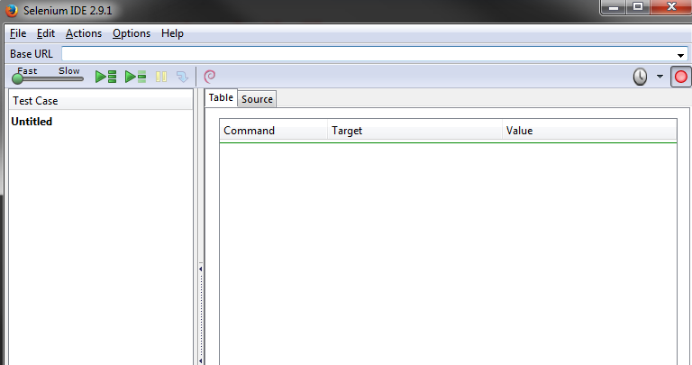
5. In the Base URL bar, enter this URL: <https://csunix.mohawkcollege.ca/tooltime/comp10066>
6. Select the File dropdown menu, click on Open Test Suite. Navigate to ADMIN_1 in the Lab3 folder and click on ADMIN_1 file.
7. To run the entire ADMIN_1 test suite just click on the “Play entire test suite” button right below the Base URL bar.
8. The test results will display at the bottom of the window.
9. To run other test suites repeat step 6 with different suite folder.

# Bug Summary

|  |  |  |
| --- | --- | --- |
| Test Name | Functionality | Comments |
| ADMIN_1  Create User Bad Inputs | Attempt to create an user using bad inputs | Typo found on error message for Company Id.  Messages says “Computer Id is not filled in.” |